**Ideation Phase**

**Empathize & Discover**

|  |  |
| --- | --- |
| Date | 31 January 2025 |
| Team ID | LTVIP2025TMID53135 |
| Project Name | *LearnHub: Your Center for Skill Enhancement* |
| Maximum Marks | 4 Marks |

**Empathy Map Canvas:**

An empathy map is a simple, easy-to-digest visual that captures knowledge about a user’s behaviours and attitudes.

It is a useful tool to helps teams better understand their users.

Creating an effective solution requires understanding the true problem and the person who is experiencing it. The exercise of creating the map helps participants consider things from the user’s perspective along with his or her goals and challenges.

**Example:**

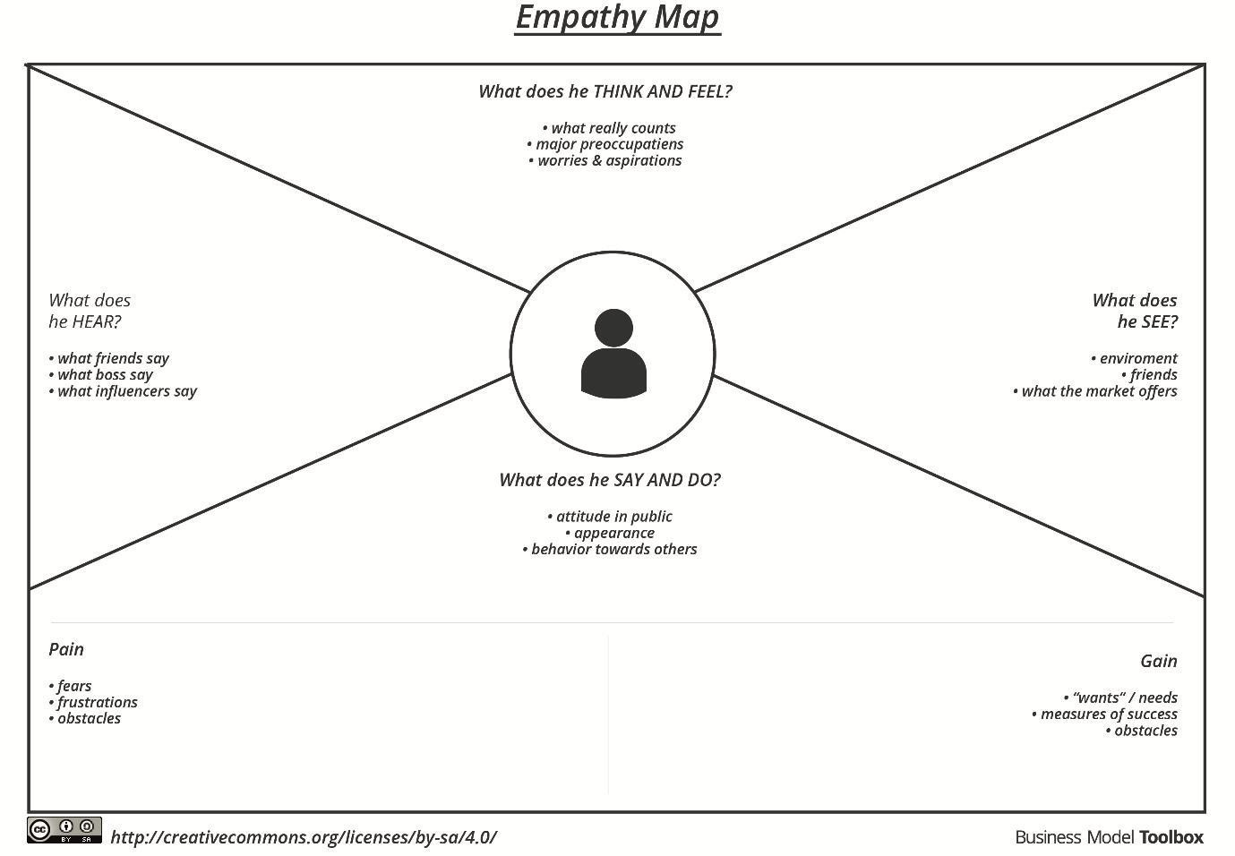

Reference: <https://www.mural.co/templates/empathy-map-canvas>

**Empathy Map Canvas for Student (Sarah)**

**Thinks**

I want to learn web development but don’t know where to start.

It should be affordable and beginner-friendly.

**Feels**

Anxious about the future.

Excited to learn new skills.

Worried about costs.

**Says**

I wish I could find a flexible course that fits my schedule.

I need something that helps me build a portfolio.

**Does**

Searches YouTube tutorials.

Asks friends for advice.

Tries free learning platforms.

Joins online forums or communities.

**Pain**

Overwhelmed by too many platforms.

Uncertainty about which platform is trustworthy or best.

**Gain**

Wants job-ready skills and certificates.

Wants community support and mentorship.

Flexible learning options.